|  |
| --- |
| 4 Finance Training Center |
| December 17,2022 |

# Overview

## Contributors:

|  |  |
| --- | --- |
|  | Jana Mahmoud  Jessica Amatoury  Rasha Al Bitar |

## Project background and description

|  |  |
| --- | --- |
|  | This website “Ramy’s Ecological Farm” contains information about ecological farm.  It’s an informative website that includes healthy ecological projects focusing on the interaction between the plants and the environment. |

## Project scope

Website contains one page:

**Home Page:**

* Header: name + menu (philosophy - mission – activities - contact us)
* Main Section: image + logo
* Philosophy: Description + image
* Mission: Description + image
* Activities: list of activities + image
* Contact Us: WhatsApp + email + social media platforms

Header includes name (Ramy’s Ecological Farm) with 4 menu buttons that navigate directly to each section.

|  |  |  |  |  |
| --- | --- | --- | --- | --- |
| **Ramy’s Ecological Farm** | **Philosophy** | **Mission** | **Activities** | **Contact us** |

Main section is the first section that is directly under the header. It contains the logo with an image.

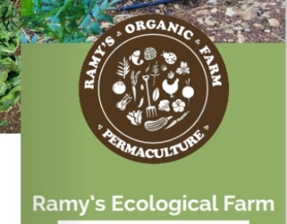

Philosophy and Mission section contains a description and images. 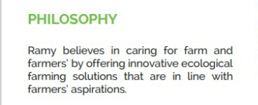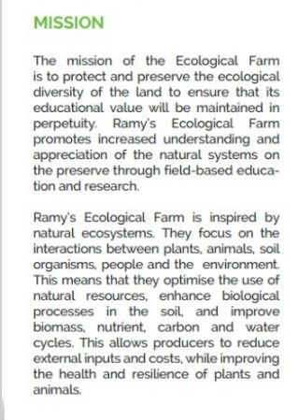

Activities section contains a list of activities. Each one with its own description and images. It also contains a show more button to load more activities. 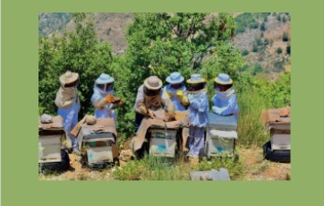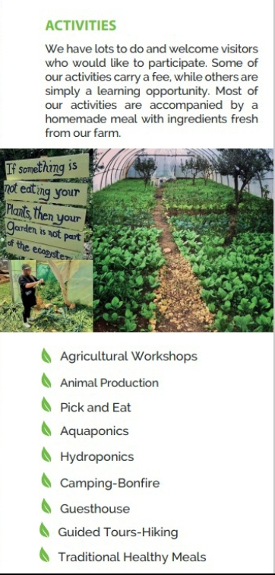

Contact us section containing profile photo, phone number, email and social media platforms.



# Approval and Authority to Proceed

We approve the project as described above, and authorize the team to proceed.

|  |  |  |  |  |  |
| --- | --- | --- | --- | --- | --- |
| Approved By |  | Date | Approved By |  | Date |